CHAPTER 1

NO SOLUTIONS REQUIRED

CHAPTER 2

WATER RESOURCES PLANNING AND MANAGEMENT

  - The Internet is an excellent source of information on this topic. The level of integrated water resources management varies by state.

  - Virtually all of the laws listed in Table 2.1 provide some protection for preventing and controlling water pollution. Information on each law may be found on the Internet. It is also important to note that the EPA only regulates at the Federal level and much of the cleanup and protection is now delegated to states and local governments.

  - Point source pollution = Pollution that originates at one location with discrete discharge points. Typical examples include industrial and wastewater treatment facilities. Nonpoint source pollution = Pollution that is usually input into the environment in a dispersed manner. Typical examples include stormwater runoff that contains fertilizers, pesticides, herbicides, oils, grease, bacteria, viruses, and salts.

  - Adverse health effects of toxic pollutants are numerous and can include a variety of conditions. Some pollutant-related conditions include asthma, nausea, and various cancers—among many others.

  - Agencies that are responsible for water quantity and quality significantly vary by state.

  - This is a subjective question and one that has been and will continue to be debated in the water resources community.

  - Integrated water resources management is difficult to achieve because it involves both a financial and resources investment over time. It is also important to obtain concensus on this approach from all of the involved stakeholders. This difficulty is perhaps why there are so few examples of true integrated water resources management.

  - This question is subjective but the student should research specific examples to support their argument.

CHAPTER 3

THE HYDROLOGIC CYCLE AND NATURAL WATER SOURCES

  - The answer to this question will vary by location.

3.2 reservoir area = 3900/640 = 6.1 sq. mi.
annual runoff = (14/12)(190 – 6.1)(640) = 137,704 ac-ft
annual evaporation = (49/12)(3900) = 15,925 ac-ft
draft = (100 X 365 X 10⁶)/(7.48 X 43,560) = 112,022 ac-ft
precipitation on lake = (40/12)(3900) = 13,000 ac-ft
gain in storage = 137,704 + 13,000 = 150,704
loss in storage = 112,022 + 15,925 = 127,947
net gain in storage = 22,757 ac-ft

  - reservoir area = 1700 hec = 17 X 10⁶ sq. meters
annual runoff = 0.3(500 X 10⁶ – 17 X 10⁶) = 144 X 10⁶ sq. meters
annual evaporation = 1.2 X 17 X 10⁶ = 20.4 X 10⁶ sq. meters
draft = 4.8 X 24 X 60 X 60 X 365 = 151.37 X 10⁶ m³
precipitation on lake = 0.97 X 17 X 10⁶ = 16.49 X10⁶ m³
gain in storage = 144 X 10⁶ +16.49 X 10⁶ = 160.49 10⁶
loss in storage = 151.37 X 10⁶ + 20.4 X 10⁶ = 171.77 X 10⁶
net loss in storage = 11.28 X 10⁶ m³

  - To complete a water budget, it is first important to understand how the water budget will be used and what time step will be necessary to successfully model the system. Once the budget is conceptually designed, a variety of online sources can usually be used to collect the data. These sources include—but are not limited to:

- state regulatory agencies
- special water districts
- weather agencies,
- local governments
- geological surveys
- agricultural agencies

Historical data and previous reports can also yield important information on the system. Verification and calibration data should also be considered as part of the data collection effort.

  - The solution for this problem will vary based on location.

3.6
Event (n) | Precip (inches) | Tr = n/m | Freq. (% years)
1 | 33 | 10 | 10
2 | 29 | 5 | 20
3 | 28 | 3.33 | 30
4 | 28 | 2.5 | 40
5 | 27 | 2 | 50
6 | 26 | 1.67 | 60
7 | 22 | 1.4 | 70
8 | 21 | 1.25 | 80
9 | 19 | 1.1 | 90
10 | 18 | 1 | 100

n = 10, m = rank, Tr = n/m, Freq = (1/Tr) X 100 Then plot precipitation versus frequency.

3.7

Event (n) | Precip (inches) | Tr = n/m | Freq. (% years)
1 | 89 | 10 | 10
2 | 75 | 5 | 20
3 | 72 | 3.33 | 30
4 | 70 | 2.5 | 40
5 | 69 | 2 | 50
6 | 66 | 1.67 | 60
7 | 56 | 1.4 | 70
8 | 54 | 1.25 | 80
9 | 48 | 1.1 | 90
10 | 46 | 1 | 100

n = 10, m = rank, Tr = n/m, Freq = (1/Tr) X 100 Then plot precipitation versus frequency.

  - Once the data is organized in a table (see below), the solution can be found. Note that the cumulative max deficiency is 131.5 mg/mi², which occurs in September. The number of months of draft is 131.5/(448/12) = 3.53. Therefore, enough storage is needed to supply the region for about 3.5 months.

Month | Inflow I | Draft O | Cumulative Inflow Σ I | Deficiency  O - I | Cumulative Deficiency  Σ (O – I)*
Feb | 31 | 37.3 | 31 | 6.3 | 6.3
March | 54 | 37.3 | 85 | -16.7 | 0
April | 90 | 37.3 | 175 | -52.7 | 0
May | 10 | 37.3 | 185 | 27.3 | 27.3
June | 7 | 37.3 | 192 | 30.3 | 57.6
July | 8 | 37.3 | 200 | 29.3 | 86.9
Aug | 2 | 37.3 | 202 | 35.3 | 122.2
Sep | 28 | 37.3 | 230 | 9.3 | 131.5
Oct | 42 | 37.3 | 272 | -4.7 | 126.8
Nov | 108 | 37.3 | 380 | -70.7 | 56.1
Dec | 98 | 37.3 | 478 | -60.7 | 0
Jan | 22 | 37.3 | 500 | 15.3 | 15.3
Feb | 50 | 37.3 | 550 | -12.7 | 2.6
* Only positive values of cumulative deficiency are tabulated.

  - S = 128,000/10*100*640 = 0.20

3.10 S = 0.0002 = volume of water pumped divided by the average decline in piezometric head times surface area

0.0002 = V/(400 X 100)
Noting that there are 640 acres per square mile
V = 0.0002 X 400 X 100 X 640 = 5120 acre-feet

3.11 Draft = (0.726 mgd) X (30 days/mo) = 21.8 mg/month
Month | Inflow I | Draft O | Deficiency  O - I | Cumulative Deficiency  Σ (O – I)*
April | 97 | 21.8 | -75.2 | 0
May | 136 | 21.8 | -114.2 | 0
June | 59 | 21.8 | 37.2 | 0
July | 14 | 21.8 | 7.8 | 7.8
Aug | 6 | 21.8 | 15.8 | 23.6
Sep | 5 | 21.8 | 16.8 | 40.43
Oct | 3 | 21.8 | 18.8 | 59.2
Nov | 7 | 21.8 | 14.8 | 74
Dec | 19 | 21.8 | 2.8 | 76.8
Jan | 13 | 21.8 | 8.8 | 85.6
Feb | 74 | 21.8 | -52.2 | 33.4*
March | 96 | 21.8 | -74.2 | 0
April | 37 | 21.8 | -15.2 | 0
May | 63 | 21.8 | -41.2 | 0
June | 49 | 21.8 | -27.2 | 0
*Maximum storage deficiency is January 85.6 mg/mo/sq. mi.
Storage capacity = 85.6 mg/mo/sq.mi.

  - P_{n} = (1 – 1/Tr)^{n}
log P_{n} = n Log (1 – 1/Tr)
n = log P_{n}/log (1 – 1/Tr)
A straight line can be defined by this equation and the following probability curves will appear.

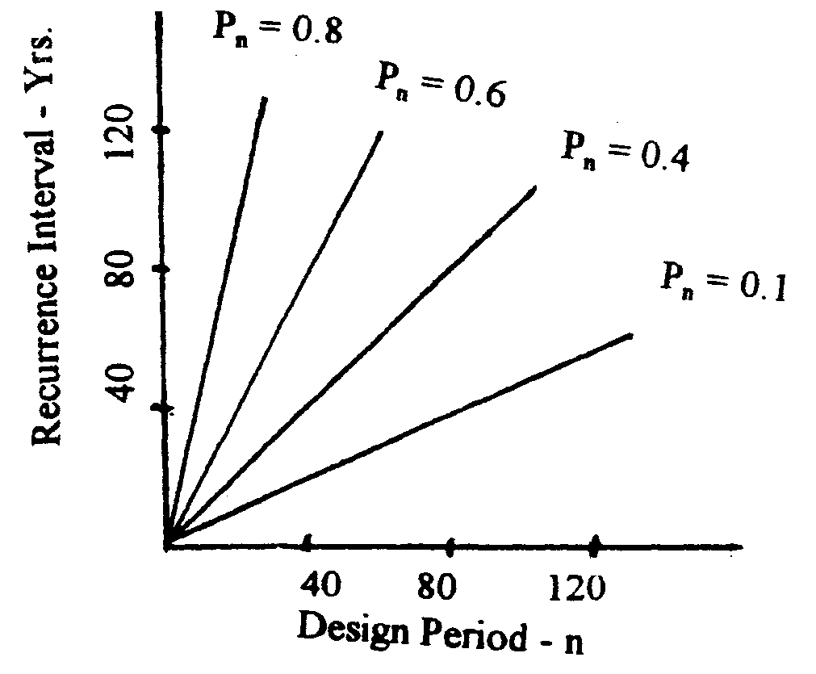

  - 20 month flow equals the sum of 12 + 11 + 10 + 12 + … + 6 + 7 + 9 = 169 cfs

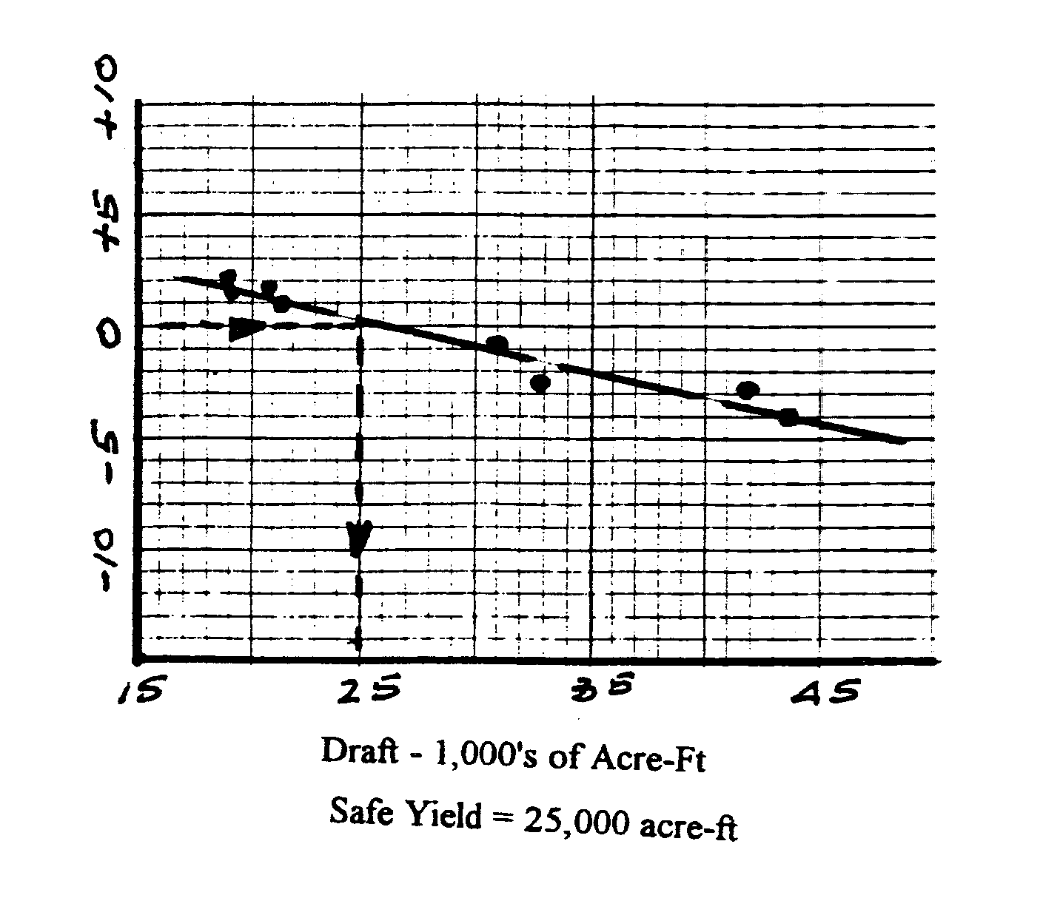

3.15
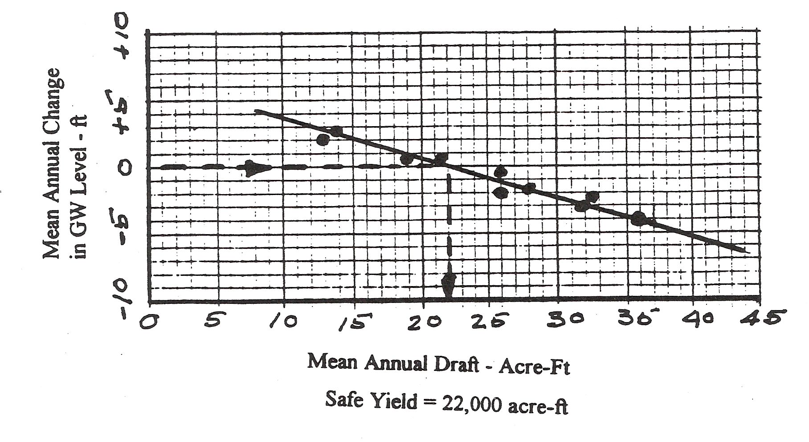

  - Reservoir capacity = 750 acre-feet
Reservoir yield is the amount of water which can be supplied during a specified time period. Assume the reservoir is to be operated continuously for 1 year without recharge. Also assume that evaporation, seepage, and other losses are zero.
Max continuous yield is 750 acre-ft/year
Or 750 X 43,560 X 0.304 = 917, 846 cubic meters per year
Or 750 X 43,560 X 7.48 X 365 X 24 X 60 = 465 gpm continuously for 1 year

  - Constant annual yield = 1500 gpm
Reservoir capacity = ? Time of operation without recharge = 1 yr
Res. Capacity = 1500 X 365 X 24 X 60 X 0.134 X (1/43,560) = 2,425 ac-ft/yr
This storage will provide a yield of 1,500 gpm for one year without any recharge

  - mean draft = 100 mgd, catchment area = 150 sq. mi., reservoir area = 4000 acres
rainfall = 38 inches, runoff = 13 inches, evaporation = 49 inches (mean annual)

- gain or loss in storage = ?
ΔS = rainfall + runoff – evaporation – draft
rainfall = 38 X 4000 X (1/12) = 12,667 ac-ft
runoff = [(150 X 640) – 4000] X 13 X (1/12) = 99,967 ac-ft
evaporation = 49 X 4000 X (1/12) = 16,333 ac-ft
draft = 100,000,000 X 365 X 0.134 X (43,560) = 112,282 ac-ft
ΔS = 12,667 + 99,667 – 16,333 – 112,282 = -16,281 ac-ft
The net loss in storage is 16, 281 ac-ft

- volume of water evaporated = 16,333 ac-ft
given a community of 100,000 people, assume a consumption of 150 gpcd
water demand = 100,000 X 150 X 365 = 5,475 mg/year
volume evaporated = 16,333 X 43,560 X 7.48 = 5,304 mg/year
evaporated water could supply the community with their water needs for
5304/5475 = 0.97 or for about one year

3.19 Use equation 3.29
K = 0.000287
h = 43
m = 8
n = 15
q = 0.000287*8*43/15 = 0.006582
Total Q is therefore 50*0.006582 = 0.325 cfs

