# **Chapter 1**

The Accounting Equation and Recording Journal Entries

Name: ______________________________

Class: ______________________________

Date: ______________________________

## Display the Accounting Equation

1. What represents amounts owed to entities outside of a business?
2. Assets
3. Liabilities
4. Receivables
5. Equity
6. Which of these describes the accounting equation?
7. Owner’s Equity = Profit - Liabilities
8. Profit = Revenue / Liabilities
9. Assets = Liabilities + Owner’s Equity
10. Revenue = Equity * Assets

## Enter Data and Numbers in Excel

1. If the [Enter] key on the keyboard is used to complete this entry, where will the cursor move?

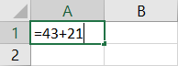

1. A2
2. B1
3. B2
4. It will remain in cell A1.
5. If the [Tab] key is used to complete this entry, where will the cursor move?



1. A2
2. B1
3. B2
4. It will remain in cell A1.
5. If the Enter button on the formula bar is used to complete this entry, where will the cursor move?



1. A2
2. B1
3. B2
4. It will remain in cell A1.
5. Which of these is considered a constant value?
6. 4,200
7. =5+81
8. =82*43
9. =9/9
10. The thick border surrounding an active cell is referred to as the _____.
11. Ribbon
12. entry
13. reference
14. highlight
15. Match each keyboard key with the impact it has on the location of the active cell.

|  |  |  |  |  |  |  |
| --- | --- | --- | --- | --- | --- | --- |
| **Keyboard Keys** | |  |  | **Where the Active Cell Moves** | | |
| A.  B. | (Enter) [Tab] | _____ _____ |  | 1. | It will move to the next cell in the applicable direction. |
| C. | (←)(↓)(↑)(→) | _____ |  | 2. | It will move down to the next cell. |
| D. | (Esc) | _____ |  | 3. | The entry is deleted, and the cell remains active. |
|  |  |  |  | 4. | It will move to the next cell to the right. |

## Record Journal Entries

1. Which statement is correct about debits?
2. A journal entry can include only one debit.
3. Debits are indented within a journal entry.
4. A debit increases the balance within a revenue account.
5. Debits appear above credits within a journal entry.
6. What is NOT a standard component of a journal entry?
7. Debited account
8. Credited amount
9. Accounting equation impact
10. Explanation
11. Which cell contains a long text entry?

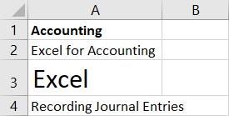

1. A1
2. A2
3. A3
4. A4
5. Which cell contains a truncated long text entry?

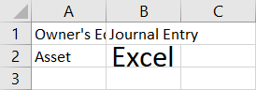

1. A1
2. A2
3. B1
4. B2
5. What feature can be used to adjust the width of column A to accommodate the text in cell A1?

Range A1:B1 with column and row headers visible. Cell A1=The Accounting Equation, with the phrase extending beyond the right border of column A.

1. Drag and drop
2. Right-dragging
3. AutoFit
4. Paste Options
5. What feature makes this menu appear?

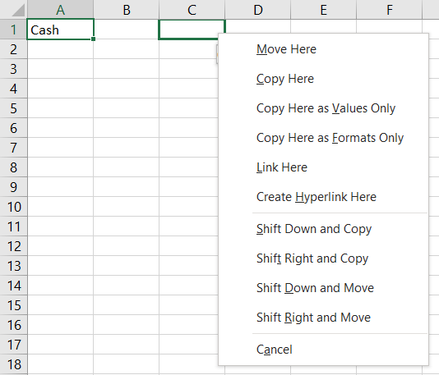

1. Drag and drop
2. Right-dragging
3. AutoFit
4. Paste Options
5. Using drag and drop results in the same outcome as using _____.
6. point and click
7. Bold and Italic
8. Undo and Redo
9. Cut and Paste
10. If the contents of cell A1 are copied and pasted into cell A3, what will appear in cell A3?

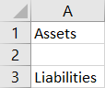

1. Liabilities
2. Nothing, the cell will be empty.
3. Liabilities Assets
4. Assets
5. Match each Excel action with its associated description.

|  |  |  |  |  |  |  |  |
| --- | --- | --- | --- | --- | --- | --- | --- |
| **Actions** | |  |  | | **Descriptions** | | |
| A.  B. | Drag and drop  Right-dragging | _____  _____ |  | 1. | | Adjust column width (or row height) to accommodate the widest (or tallest) entry. |
| C.  D. | AutoFit  Copy and Paste | _____ _____ |  | 2. | | Drag the outside border of a cell to move the contents to a new location. |
|  |  |  |  | 3. | | Move the contents of a cell to a new location without dragging the border. |
|  |  |  |  | 4. | | Drag the outside border of a cell to a new location to prompt a menu of options. |

## Use Undo and Redo in Excel

1. Which actions cannot be undone?
2. Right-dragging
3. Saving a file
4. Deleting text
5. Changing the page orientation
6. Maci notices that the Redo button is shaded and can’t be clicked, but the Undo button is active. Why?
7. She hasn’t yet issued the Undo command.
8. Excel hasn’t identified any errors for her to correct.
9. She must have printed the file.
10. You can only redo actions in the order you undid them.
11. Tyler chooses the “Typing ‘Assets’ in A1” option from the Undo menu. What happens?



1. The text “Assets” is removed from cell A1.
2. The text “Liabilities” is removed from cell A3.
3. The text in both cell A1 and cell A3 is removed.
4. Nothing; he has to undo actions from top to bottom in the list.
5. What action results in this ScreenTip being displayed?

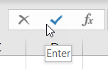

1. Hovering the mouse pointer over the Enter button
2. Clicking the Enter button and dragging down
3. Clicking the Enter button
4. Right-clicking the Enter button

## Print Worksheets

1. What action cannot be done in Backstage view?
2. Altering the print options
3. Viewing a preview of the printout
4. Navigating through the previewed worksheet pages
5. Editing the worksheet
6. What page orientation is this?

Orientation in which the paper is taller than it is wide

1. Portrait
2. Horizontal
3. Accounting
4. Landscape
5. Match each Ribbon option with its associated description.

|  |  |  |  |  |  |
| --- | --- | --- | --- | --- | --- |
| **Ribbon Options** | |  |  | **Descriptions** | |
| A. | Orientation | _____ |  | 1. | Changes the page dimensions |
| B.  C. | Size  Print Area | _____ _____ |  | 2. | Sets where one printed page ends and the next begins |
| D. | Breaks | _____ |  | 3. | Sets the page layout to either portrait or landscape |
|  |  |  |  | 4. | Allows you to identify a range of cells that will be printed |

1. Braedon completed his worksheet and is in a rush to print a portion of it, so he clicks the Quick Print button. What happens next?
2. Backstage view is displayed so he can choose the print options.
3. The worksheet is sent to the printer with the current print options in effect.
4. A menu is displayed from within the available print options for this worksheet.
5. The print preview appears.