# Chapter 1: Overview

## Concept Checks

* 1. a **1.2.** a) 4 b) 3 c) 5 d) 6 e) 2 **1.3.** a, c and e **1.4.** b **1.5.** e **1.6.** a) 4th b) 2nd c) 3rd d) 1st

## Multiple-Choice Questions

* 1. c **1.2.** c **1.3.** d **1.4.** b **1.5.** a **1.6.** b **1.7.** b **1.8.** c **1.9.** c **1.10.** b **1.11.** d **1.12.** b **1.13.** c **1.14.** a **1.15.** e **1.16.** a

## Conceptual Questions

* 1. In Europe, gas consumption is in . In the US, fuel efficiency is in miles/gallon. Let’s relate these two: 1 mile = 1.609 km, 1 gal = 3.785 L.



Therefore, is the reciprocal of 

* 1. Gas consumption is . Using  from part (a),



Therefore, a car that consumes  of gasoline has a fuel efficiency of .

* 1. If the fuel efficiency of the car is 27.4 miles per gallon, then



Therefore,  is equivalent to .

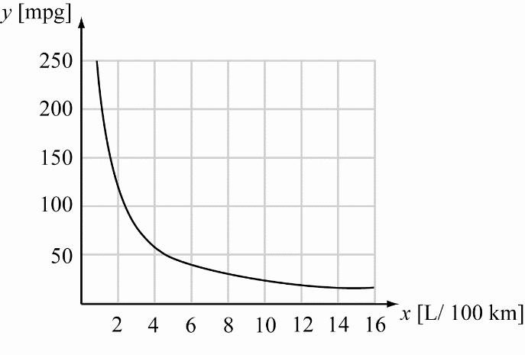

1. A vector is described by a set of components in a given coordinate system, where the components are the projections of the vector onto each coordinate axis. Therefore, on a two-dimensional sheet of paper there are two coordinates and thus, the vector is described by two components. In the real three-dimensional world, there are three coordinates and a vector is described by three components. A four-dimensional world would be described by four coordinates, and a vector would be described by four components.
2. A vector contains information about the distance between two points (the magnitude of the vector). In contrast to a scalar, it also contains information direction. In many cases knowing a direction can be as important as knowing a magnitude.
3. In order to add vectors in magnitude-direction form, each vector is expressed in terms of component vectors which lie along the coordinate axes. The corresponding components of each vector are added to obtain the components of the resultant vector. The resultant vector can then be expressed in magnitude-direction form by computing its magnitude and direction.
4. The advantage to using scientific notation is two-fold: Scientific notation is more compact (thus saving space and writing), and it also gives a more intuitive way of dealing with significant figures since you can only write the necessary significant figures and extraneous zeroes are kept in the exponent of the base.
5. The SI system of units is the preferred system of measurement due to its ease of use and clarity. The SI system is a metric system generally based on multiples of 10, and consisting of a set of standard measurement units to describe the physical world. In science, it is paramount to communicate results in the clearest and most widely understood manner. Since the SI system is internationally recognized, and its definitions are unambiguous, it is used by scientists around the world, including those in the United States.
6. It is possible to add three equal-length vectors and obtain a vector sum of zero. The vector components of the three vectors must all add to zero. Consider the following arrangement with:

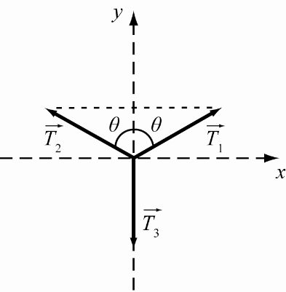

The horizontal components of  and  cancel out, so the sum  is a vertical vector whose magnitude is . The vector sum  is zero if







Therefore it is possible for three equal-length vectors to sum to zero.

1. Mass is not a vector quantity. It is a scalar quantity since it does not make sense to associate a direction with mass.
2. The volume of a sphere is given by  Doubling the volume gives  Now, since the distance between the flies is the diameter of the sphere, , and doubling the volume increases the radius by a factor of , the distance between the flies is then increased to  Therefore, the distance is increased by a factor of 
3. The volume of a cube of side  is  and the volume of a sphere of radius  is . The ratio of the volumes is:



The ratio of the volumes is independent of the value of *r*.

1. The surface area of a sphere is given by. A cube of side length  has a surface area of  To determine  set the two surface areas equal:



1. The mass of Sun is  the number of stars in the Milky Way is about the number of galaxies in the Universe is about  and the mass of an H-atom is 
2. The total mass of the Universe is roughly equal to the number of galaxies in the Universe multiplied by the number of stars in a galaxy and the mass of the average star:



1. 
2. The volume of 1 teaspoon is about , and the volume of water in the oceans is about 



There are about  teaspoons of water in the Earth’s oceans.

1. The average arm-span of an adult human is *d* = 2 m. Therefore, with arms fully extended, a person takes up a circular area of  Since there are approximately  humans, the amount of land area required for all humans to stand without being able to touch each other is  The area of the United States is about  or . In the United States there is almost five hundred times the amount of land necessary for all of the population of Earth to stand without touching each other.
2. The diameter of a gold atom is about The circumference of the neck of an adult is roughly 0.40 m. The number of gold atoms necessary to link to make a necklace is given by:



The Earth has a circumference at the equator of about. The number of gold atoms necessary to link to make a chain that encircles the Earth is given by:



Since one mole of substance is equivalent to about , the necklace of gold atoms has  moles of gold. The gold chain has  moles of gold.

1. The average dairy cow has a mass of about  Estimate the cow’s average density to be that of water, 



Relate this to the volume of a sphere to obtain the radius.



A cow can be roughly approximated by a sphere with a radius of 0.62 m.

1. The mass of a head can be estimated first approximating its volume. A rough approximation to the shape of a head is a cylinder. To obtain the volume from the circumference, recall that the circumference is , which gives a radius of  The volume is then:

*V* =

The circumference of a head is about 55 cm = 0.55 m, and its height is about 20 cm = 0.20 m. These values can be used in the volume equation:



Assuming that the density of the head is about the same as the density of water, the mass of a head can then be estimated as follows:



1. The average adult human head is roughly a cylinder 15 cm in diameter and 20. cm in height. Assume about  of the surface area of the head is covered by hair.





On average, the density of hair on the scalp is  Therefore, you have  hairs on your head.



## Exercises

1. (a) Three (b) Four (c) One (d) Six (e) One (f) Two (g) Three
2. **THINK:** The known quantities are: and  Both  and  are in the same direction, and act on the same object. The total force acting on the object is 

**SKETCH:**

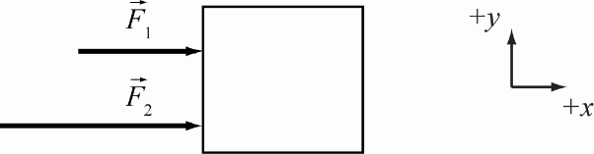

**RESEARCH:** Forces that act in the same direction are summed, 

**SIMPLIFY: **

**CALCULATE: **

**ROUND:** When adding (or subtracting), the precision of the result is limited by the least precise value used in the calculation.  is precise to four places after the decimal and  is precise to only two places after the decimal, so the result should be precise to two places after the decimal: 

**DOUBLE-CHECK:** This result is reasonable as it is greater than each of the individual forces acting on the object.

1. The result should have the same number of decimal places as the number with the fewest of them. Therefore, the result is 2.0600 + 3.163 + 1.12 = 6.34.
2. In a product of values, the result should have as many significant figures as the value with the smallest number of significant figures. The value for *x* only has two significant figures, so *w* =
3. Write “one ten-millionth of a centimeter” in scientific notation. One millionth is . Therefore, one ten-millionth is
4. 
5. There are 12 inches in a foot and 5280 feet in a mile. Therefore there are .  Rounding to six significant figures and expressing the answer in scientific notation gives .
6. (a) kilo (b) centi (c) milli
7. 
8. 1 hectare = 100 ares, and 1 are =  so:



1. 1 milliPascal
2. **THINK:** The known quantities are the masses of the four sugar cubes. Crushing the sugar cubes doesn’t change the mass. Their masses, written in standard SI units, using scientific notation are , ,  and 

**SKETCH:** A sketch is not needed to solve this problem.

**RESEARCH:**

1. The total mass equals the sum of the individual masses: 
2. The average mass is the sum of the individual masses, divided by the total number of masses:



**SIMPLIFY:**

1. 
2. 

**CALCULATE:**

1. 





1. 

**ROUND:**

1. Rounding to three significant figures, 
2. Rounding to three significant figures, 

**DOUBLE-CHECK:** There are four sugar cubes weighing between  and so it is reasonable that their total mass is and their average mass is

1. **THINK:** The cylinder has height *h* = 20.5 cm and radius *r* = 11.9 cm.

**SKETCH:**

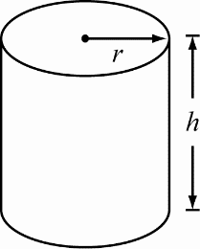

**RESEARCH:** The surface area of a cylinder is 

**SIMPLIFY: **

**CALCULATE:** 

**ROUND:** Three significant figures: 

**DOUBLE-CHECK:** The units of area are a measure of distance squared so the answer is reasonable.

1. **THINK:** When you step on the bathroom scale, your mass and gravity exert a force on the scale and the scale displays your weight. The given quantity is your mass  Pounds can be converted to SI units using the conversion  Let your mass in kilograms be 

**SKETCH:** A sketch is not needed to solve this problem.

**RESEARCH: **

**SIMPLIFY:** It is not necessary to simplify.

**CALCULATE:** 

**ROUND:** The given quantity and conversion factor contain four significant figures, so the result must be rounded to 56.88 kg.

**DOUBLE-CHECK:** The SI units of mass are kg, so the units are correct.

1. **THINK:** The orbital distance from the center of the Moon to the center of the Earth ranges from 356,000 km to 407,000 km. Recall the conversion factor 1 mile = 1.609344 kilometer.

**SKETCH:**

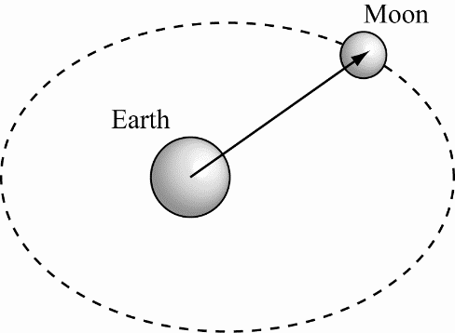

**RESEARCH:** Let  be a distance in kilometers, and  the equivalent distance in miles. The formula to convert from kilometers to miles is **.**

**SIMPLIFY:** It is not necessary to simplify.

**CALCULATE:** 



**ROUND:** The given quantities have three significant figures, so the calculated values must be rounded to 221,000 miles and 253,000 miles respectively.

**DOUBLE-CHECK:** A kilometer is roughly  of a mile, and the answers are roughly  of the given values, so the conversions appear correct.

1. **THINK:** It is a distance *d* = 60 feet, 6 inches from the pitcher’s mound to home plate. Recall the conversion factors: 1 foot = 12 inches, 1 inch = 2.54 cm, 100 cm = 1 m.

**SKETCH:**

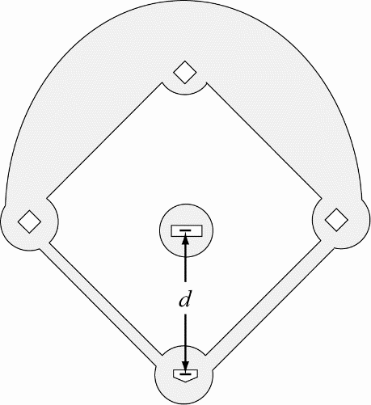

**RESEARCH:** If the distance is *x* in meters and *y* in feet, then using the conversion factor *c*,  

**SIMPLIFY:** 

**CALCULATE:** 60 feet plus 6 inches = 60.5 feet. Then, converting 60.5 feet to meters: 

**ROUND:** Rounding to three significant figures, the distance is 18.4 m.

**DOUBLE-CHECK:** The answer is a reasonable distance for a pitcher to throw the ball.

1. **THINK:** The given quantities, written in scientific notation and in units of meters, are: the starting position,  and the lengths of the flea’s successive hops, , , , ,  and  The flea makes six jumps in total.

**SKETCH:**

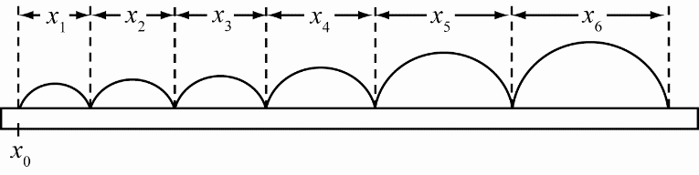

**RESEARCH:** The total distance jumped is  The average distance covered in a single hop is:



**SIMPLIFY:** **, **

**CALCULATE:** 



**ROUND:** Each of the hopping distances is measured to 1 mm precision. Therefore the total distance should also only be quoted to 1 mm precision:  Rounding the average distance to the right number of significant digits, however, requires a few more words. As a general rule of thumb the average distance should be quoted to the same precision as the least precision of the individual distances, if there are only a few measurements contributing to the average. This is the case here, and so we state  However, suppose we had 10,000 measurements contributing to an average. Surely we could then specify the average to a higher precision. The rule of thumb is that we can add one additional significant digit for every order of magnitude of the number of independent measurements contributing to an average. You see that the answer to this problem is yet another indication that specifying the correct number of significant figures can be complicated and sometimes outright tricky!

**DOUBLE-CHECK:** The flea made 6 hops, ranging from  to, so the total distance covered is reasonable. The average distance per hop falls in the range between and  which is what is expected.

1. **THINK:** The question says that of water has a mass of 1 g, that , and that 1 metric ton is 1000 kg.

**SKETCH:**

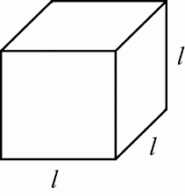

**RESEARCH:** For the first part of the question, use the conversion equation:

.

For the second part of the question, use:

.

For the last part, recall that the volume of a cube is 

**SIMPLIFY:** Re-arranging the formula for the volume of the cubical tank to solve for the length gives 

**CALCULATE:** 





**ROUND:** No rounding is necessary.

**DOUBLE-CHECK:** In each calculation the units work out correctly, so the answers are reasonable.

1. **THINK:** The given quantity is the speed limit, which is 45 miles per hour. The question asks for the speed limit in millifurlongs per microfortnight. The conversions , and 1 fortnight = 2 weeks are given in the question.

**SKETCH:** A sketch is not needed.

**RESEARCH:**



**SIMPLIFY:** 

**CALCULATE: **

**ROUND:** Because the given quantity contains two significant figures, the result must be rounded to remain consistent. A speed of 45 miles per hour is equivalent to a speed of 120 millifurlongs/microfortnight.

**DOUBLE-CHECK:** The conversion factor works out to be roughly 3 millifurlongs per microfortnight to each mile per hour, so the answer is reasonable.

1. **THINK:** The density of water is  Determine if a pint of water weighs a pound. Remember that 1.00 kg = 2.21 lbs and 1.00 fluid ounce = 29.6 mL.

**SKETCH:** A sketch is not needed.

**RESEARCH:** 1 pint = 16 fluid ounces, mass = density volume

**SIMPLIFY:** 

**CALCULATE:** 

In pounds *m* is equal to .

**ROUND:** Rounding to three significant figures, the weight is 1.05 lbs.

**DOUBLE-CHECK:** A pint is still a common measure for beverages, such as beer. A beer is relatively light and mainly comprised of water, so the answer is reasonable.

1. **THINK:** The radius of a planet, , is 8.7 times greater than the Earth’s radius, . Determine how many times bigger the surface area of the planet is compared to the Earth’s. Assume the planets are perfect spheres.

**SKETCH:**

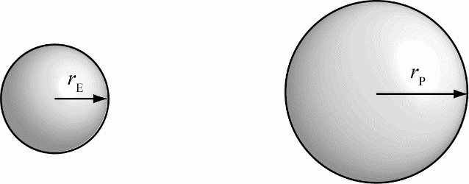

**RESEARCH:** The surface area of a sphere is so  and , and 

**SIMPLIFY:** 

**CALCULATE:**  and . By comparison, .

**ROUND:** Rounding to two significant figures, the surface area of the planet is 76 times the surface area of Earth.

**DOUBLE-CHECK:** Since the area is proportional to the radius squared, it is expected that the surface area of the planet will be much larger than the surface area of the Earth, since its radius is 8.7 times Earth’s radius.

1. **THINK:** The radius of the planet  is 5.8 times larger than the Earth’s radius . Assume the planets are perfect spheres.

**SKETCH:**



**RESEARCH:** The volume of a sphere is given by . The volume of the planet is . The volume of the Earth is . 

**SIMPLIFY:** 

**CALCULATE: ** Recall,  Comparing the expressions,.

**ROUND:** To two significant figures, so.

**DOUBLE-CHECK:** The volume of the planet is about 200 times the volume of the Earth. The volume of a sphere is proportional to the radius cubed, it is reasonable to get a much larger volume for the planet compared to the Earth’s volume.

1. **THINK:** It is necessary to take the height of both masts and the curvature of the Earth into account when calculating the distance at which they can see one another. If the ships are at the maximum distance at which the sailors can see one another, then the line between the first sailor and the second sailor will be tangent to the surface of the earth.

**SKETCH:** Since it is necessary to take the curvature of the earth into account when solving this problem, the sketch will not be to scale. The radius of the Earth is labeled *R* and the center of the earth is labeled *C*. The farthest point on the horizon that can be seen by both sailors, which is also the point at which the line of sight between them is tangent to the Earth, is labeled *A*. The distance from the first sailor to point *A* is and the distance from the second sailor to point *A* is .

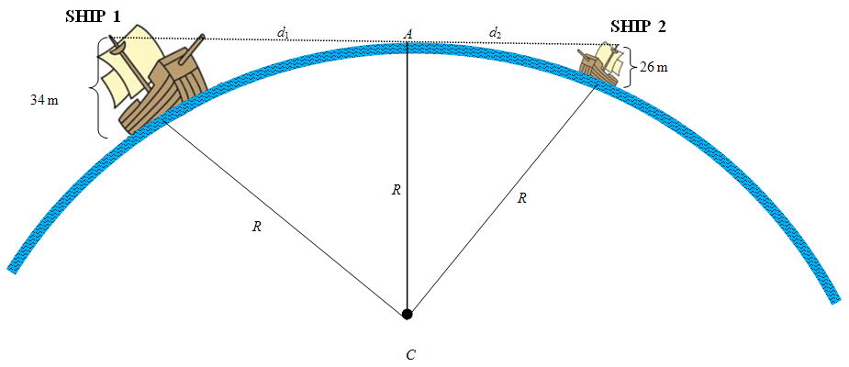

**RESEARCH:** Because the line of sight between the sailors is tangent to the earth, it is perpendicular to the radius of the earth at point *A*. This means that the triangle formed by the first sailor, point *A*, and the center of the earth (point *C*) is a right triangle. The second sailor, point *A*, and point *C* also form a right triangle. Examining the figure, we can use the Pythagorean Theorem to find equations relating  and  to *R*: and . The total distance will be the sum .

**SIMPLIFY:** First find expressions for the distances  and  and then use those to find the sum. The equation for  gives:







Similar calculations are used to find :







Combine to get an expression for the total distance between the ships: .

**CALCULATE:** The radius of the earth is given in Solved Problem 1.2 as. Using this gives a final answer of:





**ROUND:** The radius of the earth used in this problem is known to three significant figures. However, the heights of the masts of the two ships are given to two significant figures. So, the final answer should have two significant figures: 

**DOUBLE-CHECK:** The maximum distance between the ships is a distance, so the units of meters seem correct. The calculated maximum distance at which the two sailors can see one another is 39 km. Calculating



and



confirms that the sailor from ship 1, sitting at the top of a slightly taller mast, can see about 3 km further than his companion. These distances seem reasonable: an average person looking out over the ocean sees about 4.7 km, and the view from 413 m atop the Willis Tower was calculated to be 72.5 km. Since the masts are significantly taller than a person but much shorter than the height of the Willis Tower, the final answer of 39 km seems reasonable.

An alternate way to calculate this would have been to use the secant-tangent theorem, which states that the square of the distance from the sailor to the horizon equals the product the height of the mast times the sum of the height of the mast and the diameter of the earth: and . Using this formula confirms the answer:







1. **THINK:** The altitude of the jet liner is given in feet, so it will be necessary to convert to meters before calculating the answer. The horizon is the furthest point that can be seen in perfect weather conditions. Since we don’t know where and when the plane is flying, we will approximate the Earth as a perfect sphere.

**SKETCH:** Since the radius of the earth is important here, the sketch will not be to scale. Point *A* is a furthest point on the horizon that can be seen from the plane, and *C* marks the center of the Earth, and *R* indicates the radius of the Earth. Point *X* is on the surface of the Earth directly opposite from where the plane is flying.

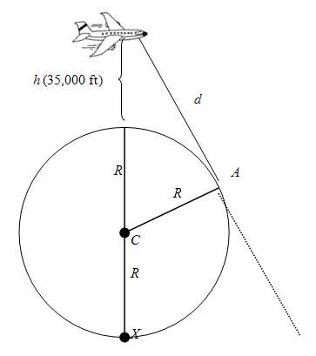

**RESEARCH:** The line of sight from the plane to the furthest point on the horizon (point *A*) is tangential to the Earth at point *A*. So, it must be perpendicular to the radius of the Earth at point *A*. This means that the plane, point *A*, and point *C* form a right triangle. The Pythagorean Theorem states that. To find the distance *d*, it is necessary to use consistent units. Since the radius of the Earth (*R*) is given in meters, it is easiest to convert the height *h* from feet to meters using the fact that   
1 m = 3.281 ft.

**SIMPLIFY:** First convert the height of the plane from feet to meters, multiplying *h* by. Then, solve the expression for *d*, the distance we want to find:







**CALCULATE:** The radius of the Earth  and the plane is flying  above the ground. Using these numbers, the distance to the horizon is

.

**ROUND:** Though it is ambiguous, the height of the jetliner above the ground is known to at least two significant figures. The radius of the Earth is known to three significant figures and the conversion from feet to meters uses four significant figures. So, the answer is known to two significant digits. This gives a final distance of  or 370 km.

**DOUBLE-CHECK:** The answer is given in units of meters or kilometers. Since the distance to the horizon is a length, the units are correct. 370 km is the approximate distance between Los Angeles and Las Vegas. Indeed, in an airplane at cruising altitude, it is just possible to see the Los Angeles coast as you fly over Las Vegas, so this answer seems reasonable. It is also possible to check the answer by working backwards. The secant-tangent theorem states that the square of the distance *d* equals the product of the height of the plane over the Earth *h* and the distance from the jetliner to point *X* on the other side of the Earth. Use this to find the height of the plane in terms of the distance to the horizon and the radius of the earth:











Converting this back to feet and rounding to 2 significant figures gives confirmation that the answer was correct:

1. **THINK:** The given quantity is 1.56 barrels of oil. Calculate how many cubic inches are in 1.56 barrels. 1 barrel of oil = 42 gallons = (42 gal)() = 9702 cubic inches.

**SKETCH:** A sketch is not needed.

**RESEARCH:** If a volume  is given in barrels then the equivalent volume  in cubic inches is given by the formula 

**SIMPLIFY:** Not applicable.

**CALCULATE:** 

**ROUND:** The value given in the question has three significant figures, so the final answer is that 1.56 barrels is equivalent to .

**DOUBLE-CHECK:** Barrels are not commonly used units. However, since the proper conversion factor of 9702 cubic inches per barrel was used, the answer is accurate.

1. **THINK:** The car’s gas tank has the shape of a rectangular box with a square base whose sides measure  The tank has only 1.5 L remaining. The question asks for the depth, *d* of the gas remaining in the tank. The car is on level ground, so that *d* is constant.

**SKETCH:**

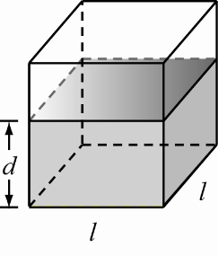

**RESEARCH:** . The volume of gas remaining is  Convert the volume 1.5 Lto  by using 

**SIMPLIFY:** , but , so substitute this into the expression for *d*: .

**CALCULATE:** 

**ROUND:** To two significant figures 

**DOUBLE-CHECK:** The car’s gas tank will hold 52 L but only has 1.5 L remaining. The sides of the gas tank are 62 cm and because the gas tank is almost empty, there should be a small depth of gas in the bottom of the tank, so the answer is reasonable.

1. **THINK:** The formula for the volume of a sphere is given by . The formula for density is given by . Refer to Appendix B in the text book and express the answers in SI units using scientific notation.

**SKETCH:**

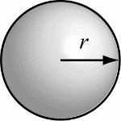

**RESEARCH:** The radius of the Sun is the mass of the Sun is  the radius of the Earth is  and the mass of the Earth is 

**SIMPLIFY:** Not applicable.

**CALCULATE:**

1. 
2. 
3. 
4. 

**ROUND:** The given values have three significant figures, so the calculated values should be rounded as:

1. 
2. 
3. 
4. 

**DOUBLE-CHECK:** The radius of the Sun is two orders of magnitude larger than the radius of the Earth. Because the volume of a sphere is proportional to the radius cubed, the volume of the Sun should be  or  larger than the volume of the Earth, so the calculated volumes are reasonable. Because density depends on mass and volume, and the Sun is roughly  times larger and more massive than the Earth, it is not surprising that the density of the Sun is on the same order of magnitude as the density of the Earth (e.g. ). Earth is primarily solid, but the Sun is gaseous, therefore it is reasonable that the Earth is denser than the Sun.

1. **THINK:** The tank is in the shape of an inverted cone with height and radius *r* = 0.75 m. Water is poured into the tank at a rate of . Calculate how long it will take to fill the tank. Recall the conversion 

**SKETCH:**

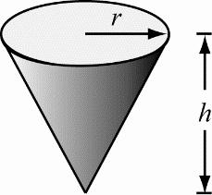

**RESEARCH:** The volume of a cone is . The rate water enters the cone is  where *t* is time. When the cone is full, , therefore 

**SIMPLIFY:** 

**CALCULATE:** 

**ROUND:** To two significant figures, *t* = 98 s.

**DOUBLE-CHECK:** The calculation resulted in the correct units, so the answer is reasonable.

1. **THINK:** The rate of water flow is , the tank is cubical, and the top surface of the water rises by . Let *h* be the height of the water in the tank.

**SKETCH:**

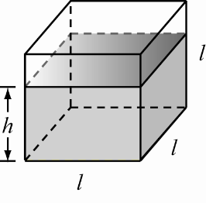

**RESEARCH:** The change in the volume of the water, , is  The change in the height of the water is  An equation to find the side length of the tank is 

**SIMPLIFY:** 

**CALCULATE:** 

**ROUND:** 

**DOUBLE-CHECK:** The flow rate of  is quite fast, but the level of the water is rising by only , so it is reasonable that the tank is relatively large.

1. **THINK:** The atmosphere has an effective weight of 15 pounds per square inch. By computing the surface area of the Earth, it will be easy to compute the mass of the atmosphere. Then, since the atmosphere is assumed to have a uniform density of  the mass can be converted to a volume. The volume of the atmosphere is the difference of two spheres, whose radii are the radius of the Earth,  and the radius of the Earth plus the thickness of the atmosphere,  The result will be a cubic equation with one real root which can be approximated to give the thickness of the atmosphere.

**SKETCH:**

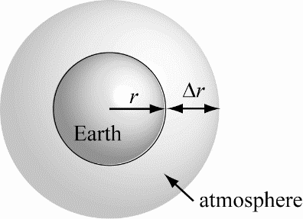

**RESEARCH:** Recall the conversions 1 inch = 0.0254 m and 1 kg = 2.205 lbs. The radius of the Earth is about 6378 km. The surface area of the Earth is. The mass of the atmosphere is  The volume of the atmosphere can be computed using the ratio where  is the density of the atmosphere. This volume is the difference of the two spheres, as shown in the sketch. The volume of the Earth (without its atmosphere) is  and the volume of the Earth and atmosphere is  A second method of computing the volume of the atmosphere is  Set the two values of  equal and solve for *r*.

**SIMPLIFY:** The first expression for the volume of the atmosphere is



The second expression is  Setting these expressions equal to each other gives an equation to solve for 

**CALCULATE:** 



Substituting into the first equation for  gives:



The second equation for becomes:



Setting the two equations for equal results in the equation:

,

a cubic equation in *.* This equation can be solved by a number of methods. A graphical estimate is sufficient. It has one real root, and that is at approximately



**ROUND:** The least precise value given in the question had two significant figures, so the answer should be rounded to 8300 m.

**DOUBLE-CHECK:** The result has units of distance, which is what is expected. What may not be expected is that our result is not as big as the height of the tallest mountain on Earth, Mt. Everest, which has a height of 8.8 km. We can obtain a simple approximation of our result by realizing that our calculated value for  is small compared to the radius of Earth. This means that the surface of a sphere with radius  and one with radius  are not very different, allowing us to write an approximation to our result as 

1. **THINK:** Let  be the position vector. Then and (above *x*-axis).

**SKETCH:**

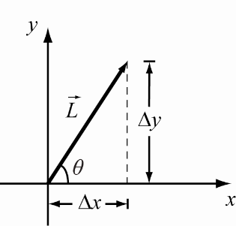

**RESEARCH:** From trigonometry,  and . The length of the vector  is given by the formula 

**SIMPLIFY: **, 

**CALCULATE: **, 

**ROUND:**  and 

**DOUBLE-CHECK: ** to three significant figures.

1. **THINK:**   and are the given quantities.

**SKETCH:**

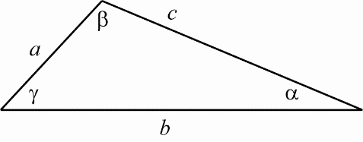

**RESEARCH:** Law of cosines: 

**SIMPLIFY:**  







**CALCULATE:** 

**ROUND:** 

**DOUBLE-CHECK:** The angle  in the figure is less than , so the answer is reasonable.

1. **THINK:** The lengths of the vectors are given as , ,  and . The question asks for the vectors to be written in terms of unit vectors. Remember, when dealing with vectors, the *x-* and *y-*components must be treated separately.

**SKETCH:**

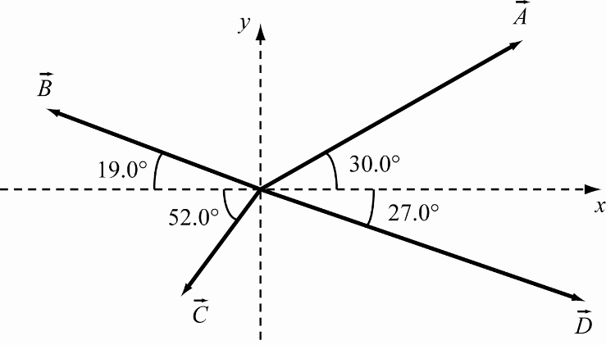

**RESEARCH:** The formula for a vector in terms of unit vectors is . Since  and ,  and .







**SIMPLIFY: **     and .

**CALCULATE:** 







**ROUND:** The given values had three significant figures so the answers must be rounded to:

.

**DOUBLE-CHECK:** Comparing the calculated components to the figure provided shows that this answer is reasonable.

1. **THINK:** Use the components in Question 1.65 to find the sum of the vectors,, and . Also, calculate the magnitude and direction of. Remember, when dealing with vectors the *x* and *y* components must be treated separately. Treat the values given in the question as accurate to the nearest decimal, and hence as having two significant figures.

**SKETCH:** Not applicable.

**RESEARCH:**

1. The resultant vector is .
2. The magnitude of a vector is . The direction of the vector  is .

**SIMPLIFY:**

1. 
2. 



**CALCULATE:**

1. 



1. 



**ROUND:**

1. Not necessary.
2. The given magnitudes have three significant figures, so , at  (below the *x*-axis).

**DOUBLE-CHECK:** The length of the resulting vector is less than the sum of the lengths of the component vectors. Since the vector points into the fourth quadrant, the angle made with the *x*-axis should be negative, as it is.

1. **THINK:** The problem involves adding vectors, therefore break the vectors up into their components and add the components. SW is exactly  south of W. ,  SW, .

**SKETCH:**

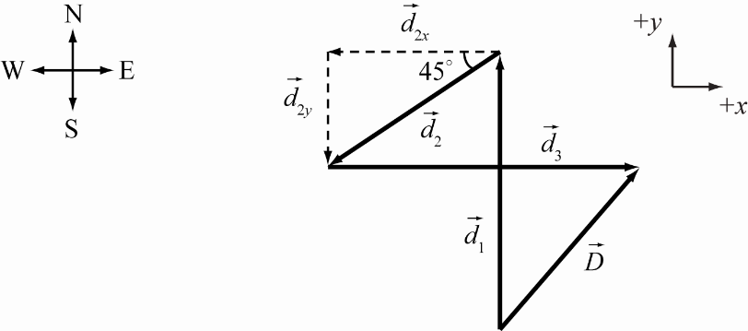

**RESEARCH:** Use , and recall the formula for the length of . Decompose each summand vector into components , with summand vectors:  

**SIMPLIFY:** Therefore,  and

.

**CALCULATE:** 

**ROUND: **

**DOUBLE-CHECK:** Given that all vectors are of the same order of magnitude, the distance from origin to final position is less than , as is evident from the sketch. This means that the calculated answer is reasonable.

1. **THINK:** The problem involves adding vectors, therefore break the vectors up into their components and add the components. NW is exactly north of west. N,  NW,  S. Paces are counted to the nearest integer, so treat the number of paces as being precise.

**SKETCH:**

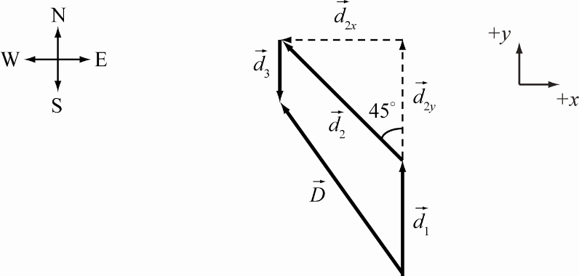

**RESEARCH:**, Use , and recall the formula for the length of . Decompose each summand vector into components , with summand vectors:   

**SIMPLIFY:**  and

.

**CALCULATE:** 

**ROUND:** 38 paces

**DOUBLE-CHECK:** Given that , the calculated answer makes sense since the distance *D* should be greater than .

1. **THINK:** The problem involves adding vectors, therefore break the vectors up into their components and add the components. NW is  north of west. , , ,  into ground ( implies 3 dimensions). Paces are counted to the nearest integer, so treat the number of paces as being precise.

**SKETCH:**

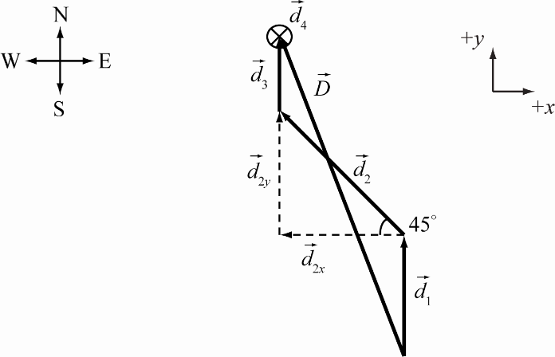

**RESEARCH:** , ,     and 

**SIMPLIFY: ** and

.

**CALCULATE: **



**ROUND: ** and round the number of paces to the nearest integer: 

**DOUBLE-CHECK:** Distance should be less than the sum of the magnitudes of each vector, which is 65. Therefore, the calculated answer is reasonable.

1. **THINK:** Consider the Sun to be the centre of a circle with the distance from the Sun to Venus, as the radius. Earth is located a distance  from the Sun, so that the three bodies make a triangle and the vector from Earth to the Sun is at 0˚. The vector pointing from Earth to Venus intersects Venus’ orbit one or two times, depending on the angle Venus makes with the Earth. This angle is at a maximum when the vector intersects the orbit only once, while all other angles cause the vector to intersect twice. If the vector only intersects the circle once, then that vector is tangential to the circle and therefore is perpendicular to the radius vector of the orbit. This means the three bodies make a right triangle with  as the hypotenuse. Simple trigonometry can then be used to solve for the angle and distance.

**SKETCH:**

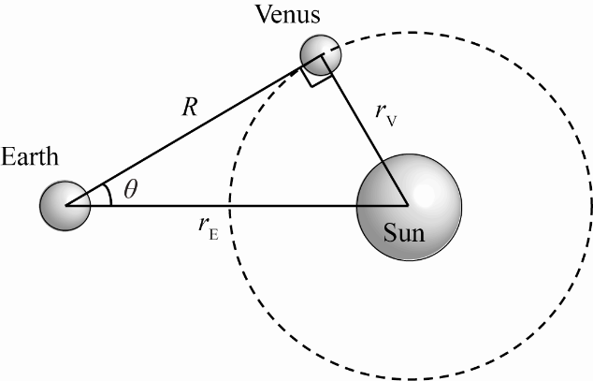

**RESEARCH:** 

**SIMPLIFY:** 

**CALCULATE:** 

**ROUND: **

**DOUBLE-CHECK:** If it had been assumed that  when the E-to-S-to-V angle was  then  would be about  Therefore the maximum angle should be greater than this, so the answer is reasonable.

1. **THINK:** All angles and directions of vectors are unknown. All that is known are the distances walked,  and , and the distance  that the friend is now away from you. Since the distances are the sides of a triangle, use the cosine law to determine the internal (and then external) angles. Also, since , he must have turned back towards you partially, i.e. he turned more than  but less than 

**SKETCH:**

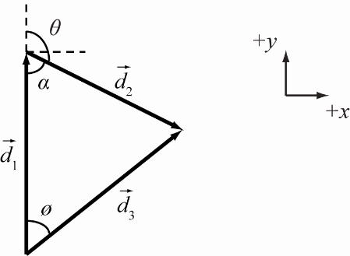

**RESEARCH:** 

**SIMPLIFY:** 

Likewise, 

**CALCULATE:**   

**ROUND:** Since  has two significant figures (which is the fewest) the answers should be rounded to two significant figures. This means: ****,  and then . The two possibilities are that the friend turned to the right or the left (a right turn is shown in the diagram). The direction the friend turned doesn’t matter, he turns by the same amount regardless of which direction it was.

**DOUBLE-CHECK:** The friend turned through an angle of 140 degrees. The angle between the initial departure and the final location is 16 degrees. These are both reasonable angles.

1. **THINK:** Assume that the Earth is a perfect sphere with radius, , and treat the circumference of Earth as the circumference of a circle.

**SKETCH:**

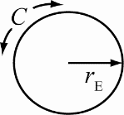

**RESEARCH:** The circumference of a circle is given by 

**SIMPLIFY:** 

**CALCULATE:** 

**ROUND:** The instructions from the question say to round to three significant figures: 

**DOUBLE-CHECK:** Assuming a hot air balloon has an average velocity of , then it would take about 80 days to travel, hence the phrase around the world in 80 days.

1. 
2.  
3. **THINK:** An angle is measured counter-clockwise from the positive *x*-axis (0˚).  It is also possible to measure clockwise from the positive *x*-axis and consider the measure to be negative.

**SKETCH:**

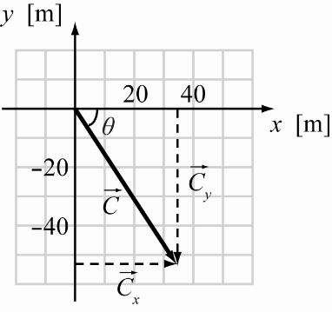

**RESEARCH:**  

**SIMPLIFY:** 

**CALCULATE:** 

**ROUND:** ,  or 303˚ (equivalent angles).

**DOUBLE-CHECK:** The magnitude is greater than each component but less than the sum of the components and the angle is also in the correct quadrant. The answer is reasonable.

1. **THINK:** Assume Mars is a sphere whose radius is 

**SKETCH:**

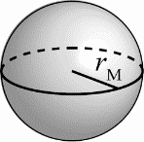

**RESEARCH: **

**SIMPLIFY:** 

**CALCULATE:** 





**ROUND:**   

**DOUBLE-CHECK:** The units are correct and the orders of magnitude are reasonable.

1. **THINK:** Sum the components of both vectors and find the magnitude and the angle from the positive *x*-axis of the resultant vector.  and .

**SKETCH:**

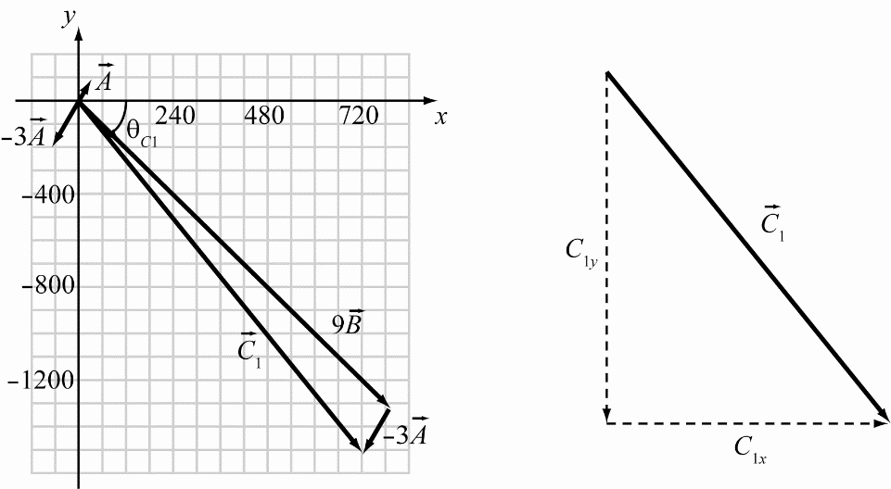

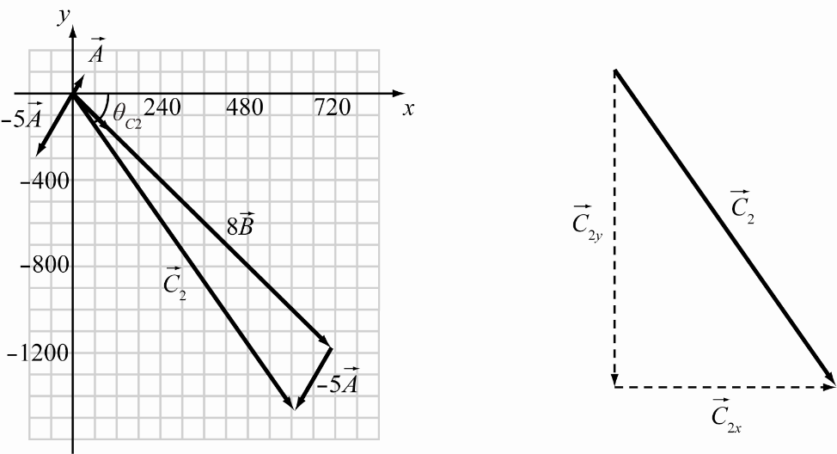

**RESEARCH:**  ,  

**SIMPLIFY:**

1. Since  and   and  Also, .
2. Since  and   and  Also, .

**CALCULATE:**

1. 



1. ** **



**ROUND:**

1.  at  or 
2.  at  or 

**DOUBLE-CHECK:** Each magnitude is greater than the components but less than the sum of the components and the angles place the vectors in the proper quadrants. The calculated answers are reasonable.

1. **THINK:** The vectors are  and  Find the magnitude and angle with respect to the positive *x*-axis for each.

**SKETCH:**

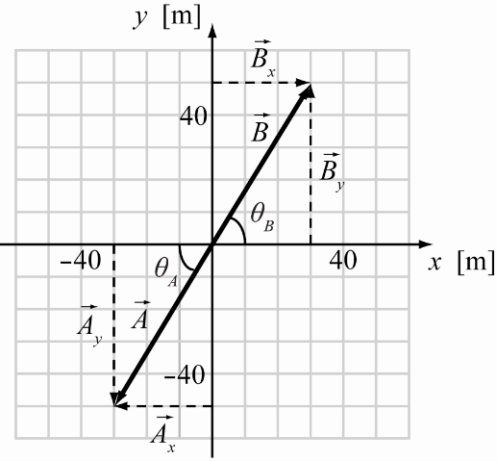

**RESEARCH:**  

**SIMPLIFY:**    

**CALCULATE: **





**ROUND:**  or , and 

**DOUBLE-CHECK:** Each magnitude is greater than the components of the vector but less than the sum of the components and the angles place the vectors in the proper quadrants.

1. **THINK:** A variable is proportional to some other variable by a constant. This means the ratio of one variable to another is a constant. Therefore, both ratios are equal. ,  and 

**SKETCH:**

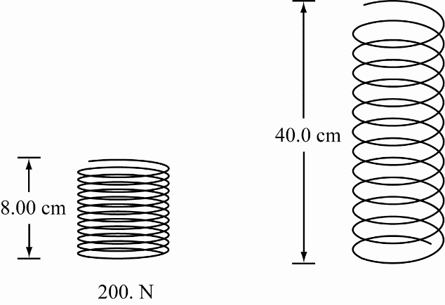

**RESEARCH:** 

**SIMPLIFY:** 

**CALCULATE:** 

**ROUND:** 

**DOUBLE-CHECK:** The ratio of distance to force remains 1:25 for the two distances. The answers are reasonable.

1. **THINK:** When a variable is proportional to another, it is equal to the other variable multiplied by a constant. Call the constant “*a*”.

**SKETCH:** A sketch is not needed to solve this problem.

**RESEARCH:** 

**SIMPLIFY:** 

**CALCULATE:**  = 

**ROUND:** The distance increases by a factor of 9.

**DOUBLE-CHECK:** Acceleration is a quadratic relationship between distance and time. It makes sense for the amount of time to increase by a factor larger than 3.

1. **THINK:** Consider the  turns to be precise turns at right angles.
2. The pilot initially flies N, then heads E, then finally heads S. Determine the vector  that points from the origin to the final point and find its magnitude. The vectors are ,  and 
3. Now that the vector pointing to the final destination has been computed,  determine the angle the vector makes with the origin. The angle the pilot needs to travel is then 180° from this angle.

(c)Before the pilot turns S, he is farthest from the origin. This is because when he starts heading S, he is negating the distance travelled N. The only vectors of interest are  and .

**SKETCH:**

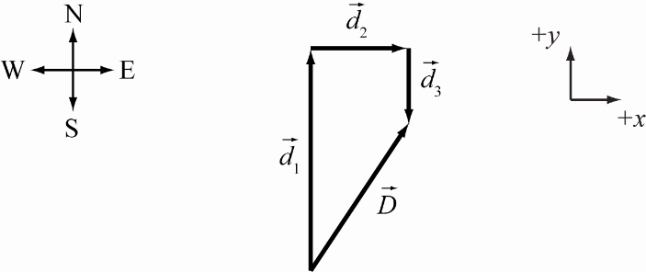

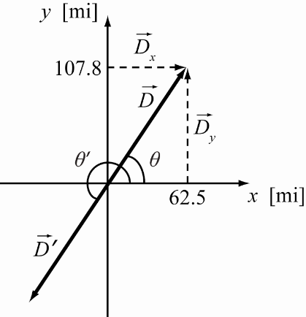

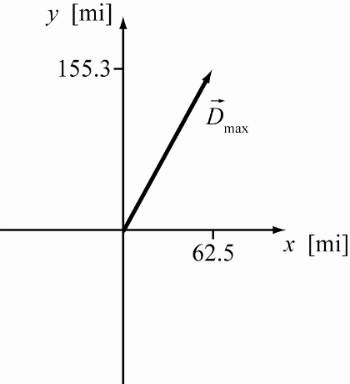

**RESEARCH:**

1.   
2. ** **
3.  ** **

**SIMPLIFY:**

1.   

Therefore,  and 

1.  and 
2.   

**CALCULATE:**

1. 



1. 



1. 

**ROUND:**

1. 
2. 
3. 

**DOUBLE-CHECK:**

1. The total distance is less than the distance travelled north, which is expected since the pilot eventually turns around and heads south.
2. The pilot is clearly NE of the origin and the angle to return must be SW.
3. This distance is greater than the distance which included the pilot travelling S, as it should be.
4. **THINK:**
5. If an observer sees the Moon fully cover the Sun, then light rays from the outer edge of the Sun are blocked by the outer edge of the Moon. This means a line pointing to the outer edge of the Moon also points to the outer edge of the Sun. This in turn means that the lines share a common angle. The radii of the Moon and Sun are, respectively,  and  The distance from the Moon to the Earth is 
6. In part (a), the origin of the light ray is assumed to be the centre of the Earth. In fact, the observer is on the surface of the Earth,  This difference in observer position should then be related to the actual distance to the Moon. The observed Earth to Moon distance remains the same,  while the actual distance is the observed distance minus the radius of the Earth.
7. Given the relative error of between the actual and observed distance to the Moon, there should be the same relative error in the difference between the observed and actual distance to the Sun. 

**SKETCH:**

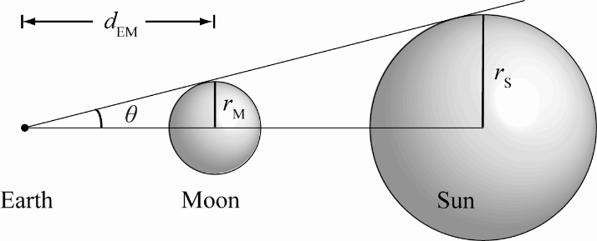

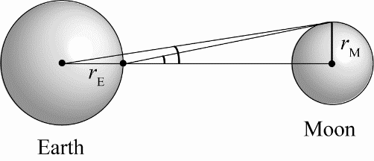

1. Not applicable.

**RESEARCH:**

1. 
2. 
3. 

**SIMPLIFY:**

1. 
2. 



1. 



**CALCULATE:**

1. 
2. 
3. 

**ROUND:**

1. 
2. 
3. 

**DOUBLE-CHECK:**

1. The distance from the Earth to the Sun is about 300 times the distance from the Earth to the Moon, so the answer is reasonable.
2. The radius of Earth is small compared to the distance from the Earth to the Moon, so the error calculated is small.
3. The relative error is small so there should be a small difference between the actual and the observed distance from the Earth to the Sun.
4. **THINK:** The problem involves adding vectors. Break the vectors into components and sum the components. The vectors are: ,  and . Find the length of the resultant, and the angle it makes with the vertical. Let 

**SKETCH:**

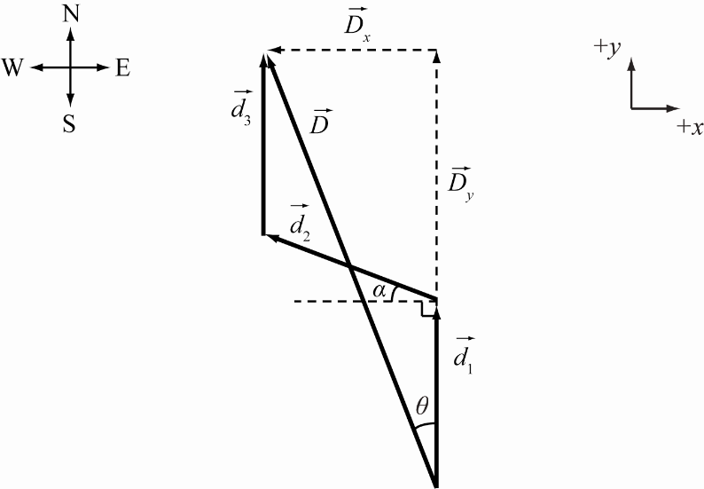

**RESEARCH:**    

**SIMPLIFY:** 





**CALCULATE:** 





**ROUND: **

**DOUBLE-CHECK:** The only directions travelled were N or NW, so the final direction should be in the NW region.

1. **THINK:** If the number of molecules is proportional to the volume, then the ratio of volumes should be the same as the ratio of the molecules. 1 mol =  molecules, volume of mol = 22.4 L and the volume of one breath is 0.500 L. Only 80.0% of the volume of one breath is nitrogen.

**SKETCH:** Not applicable.

**RESEARCH: ** 

**SIMPLIFY:** 

**CALCULATE: **

**ROUND:** 

**DOUBLE-CHECK:** Since the volume of one breath is about 50 times smaller than the volume of one mole of gas, the number of nitrogen molecules in one breath should be about 50 times smaller than the number of molecules in a mole.

1. **THINK:** 24.9 seconds of arc represents the angle subtended by a circle with diameter =  located a distance  from Earth. This value must be converted to radians. The diameter of Mars is .

**SKETCH:**

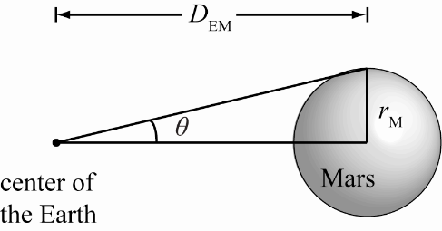

**RESEARCH:** The angular size is related to the angle  shown in the sketch by  From the sketch, we can see that



Because Mars is a long distance from the Earth, even at closet approach, we can make the approximation

**SIMPLIFY:** Putting our equations together gives us 

**CALCULATE:** We first convert the observed angular size from seconds of arc to radians



The distance is then



**ROUND:** We specify our answer to three significant figures, 

**DOUBLE-CHECK:** The mean distance from Earth to Mars is about Because the distance calculated is for a close approach and the distance is less than the mean distance, the answer is reasonable.

1. **THINK:** If the quarterback is in the exact centre of a rectangular field, then each corner should be the same distance from the centre. Only the angle changes for each corner. The width of the field is 53 1/3 yards and the length is 100. yards. Since the question states that the length is exactly 100 yards, the precision of the final answer will be limited by the width.

**SKETCH:**

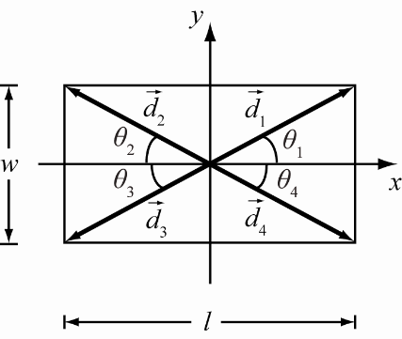

**RESEARCH:**   

**SIMPLIFY: **

**CALCULATE:**

1. 
2. 





**ROUND:**

1. 
2. 

**DOUBLE-CHECK:**  are 180° apart. This is expected when throwing at opposite corners of the field. The answers are reasonable.

1. **THINK:** Assume the Cornell Electron Storage Ring is a perfect circle with a circumference of Recall the exact conversion

**SKETCH:**

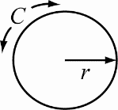

**RESEARCH:** 

**SIMPLIFY:** 

**CALCULATE:** 

**ROUND:** 

**DOUBLE-CHECK:** There are 12 inches in a foot and 5280 feet in a mile. Therefore there are . Our answer for the Cornell ring is thus about  of a mile, which seems the right order of magnitude.

1. **THINK:** 4% of the 0.5 L for each exhalation is composed of carbon dioxide. Assume 1 mole (molecules) has a volume of 22.4 L. The particular numbers are actually not that important. The only important thing is that they have the right order of magnitude. So it also could be 0.3 or 0.6 L that we exhale in each breath, which are also numbers you can find in the literature; and some sources quote 5% in the air that we breathe out.

**SKETCH:** Not applicable.

**RESEARCH:** How many times do we breathe per day? You can count the number of breaths you take in a minutes, and that number is around 15. This means that you breath around 800 to 1,000 times per hour and around 20,000 to 25,000 times per day.

, 

**SIMPLIFY:** 

**CALCULATE:** 

1. 







1. 

**ROUND:** In this case we only estimate order of magnitudes. And so it makes no sense to give more than one significant digit. We can therefore state our answer as

1. 
2. 

**DOUBLE-CHECK:** Does it makes sense that we breathe out around 300 to 400 kg of  in a year, which implies that we breathe out approximately 1 kg of  in a day. Where does this materials come from? The oxygen comes from the air we breathe in. So the carbon has to be part of what we eat each day. Since ~ of the mass of a  molecule resides in the carbon, this means that we have to eat at least ~ of a pound of carbon each day. Since carbon, hydrogen, and oxygen are the main components of our food, and since we eat several pounds of food per day, this seems in the right ballpark.

1. **THINK:** Consider the Sun to be at the centre of a circle with Mercury on its circumference. This gives  as the radius of the circle. Earth is located a distance  from the Sun so that the three bodies form a triangle. The vector from Earth to the Sun is at . The vector from Earth to Mercury intersects Mercury’s orbit once when Mercury is at a maximum angular separation from the Sun in the sky. This tangential vector is perpendicular to the radius vector of Mercury’s orbit. The three bodies form a right angle triangle with  as the hypotenuse. Trigonometry can be used to solve for the angle and distance.

**SKETCH:**

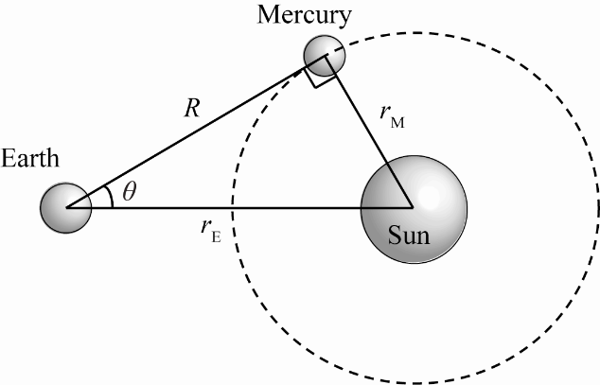

**RESEARCH:**  

**SIMPLIFY:**  

**CALCULATE:** 

**ROUND:**  

**DOUBLE-CHECK:** If it had been assumed that the maximum angular separation occurred when the Earth to Sun to Mercury angle was 90°,  would be about The maximum angle should be greater than this and it is, so the answer is reasonable.

1. **THINK:** This question asks about the distance to Proxima Centauri, which can be calculated using parallax. To do so, it will be necessary to know the radius of Earth’s orbit. It will also be necessary to convert from milliarcseconds to degrees or radians. Then, geometry should be used to find the distance.

**SKETCH:** Because of the distances involved, the diagram will not be to scale. The earth is shown at two locations, ½ year apart in its revolution around the Sun. The radius of Earth’s orbit is labeled *r* and the distance to Proxima Centauri is labeled *d*.

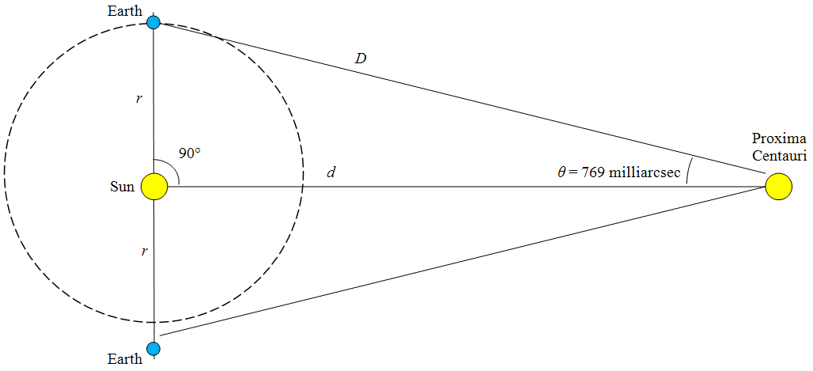

**RESEARCH:** The goal is to find *d*, the distance between the Sun and Proxima Centauri. Note that the Earth at either of the positions shown, the Sun, and Proxima Centauri form right triangles. The textbook lists the mean orbital radius of Earth as . The final answer needs to be in light-years, so it will be necessary to convert from km to light-years at some point using the fact that . Knowing the parallax and the radius of the Earth’s orbit, it is then possible to use trigonometry to find the distance *d* from the Sun to Proxima Centauri: .

**SIMPLIFY:** Using algebra to find the distance *d* in terms of *r* and *θ* gives. It is more difficult to convert from milliarcseconds to a more familiar unit of angle measure, the degree. Since there are 60 arcseconds to the arcminute, and 60 arcminutes make one degree, the conversion will look like this: 

**CALCULATE:** It is important to perform this calculation with the computer or calculator in degree (not radian) mode. Using the textbook value for the radius of the earth  and the given value for the parallax of 769 milliarcsec gives:







**ROUND:** The parallax has three significant figures. The radius of the earth is given to four, and all of the conversions are exact except light-years to km, which is given to four. So the final answer should have three figures. This gives a total distance of 4.24 light-years.

**DOUBLE-CHECK:** A distance to the Proxima Centauri of 4.24 light-years means that it takes light about 4¼ years to travel between the Sun and Proxima Centauri. Knowing what we do of astronomical scales, this makes sense.

## Multi-Version Exercises

1. **THINK:** The lengths of the *x* and *y* components of the vectors can be read from the provided figure. Remember to decompose the vectors in terms of their *x* and *y* components.

**SKETCH:**

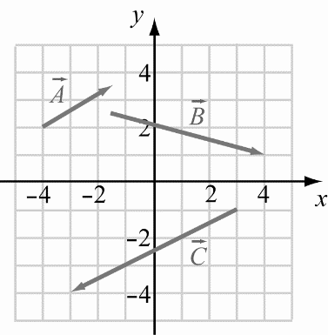

**RESEARCH:** A vector can be written as , where  and .

**SIMPLIFY:**  Not applicable.

**CALCULATE:**  

**ROUND:** Not applicable.

**DOUBLE-CHECK:** Comparing the signs of the *x*- and *y-*components of the vectors ,  and  to the provided figure, the calculated components all point in the correct directions. The answer is therefore reasonable.

1. **THINK:** The question asks for the length and direction of the three vectors. The *x* and *y* components of the vectors can be read from the provided figure. Remember when dealing with vectors, the components must be treated separately.

**SKETCH:**

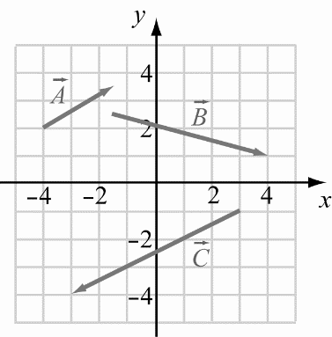

**RESEARCH:** The length of a vector is given by the formula. The direction of a vector (with respect to the *x*-axis) is given by .

**SIMPLIFY: **

**CALCULATE: **







**ROUND:** The figure can reasonably be read to two significant digits, so the rounded values are      and 

**DOUBLE-CHECK:** Comparing the graphical values to the calculated values, the calculated values are reasonable.

1. Vectors add tip to tail, .

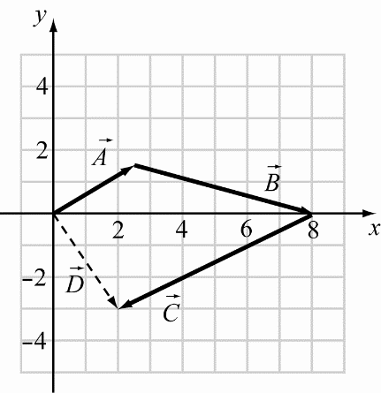

By inspecting the image, it is clear that 

1. **THINK:** To subtract two vectors, reverse the direction of the vector being subtracted, and treat the operation as a sum. Denote the difference as 

**SKETCH:**

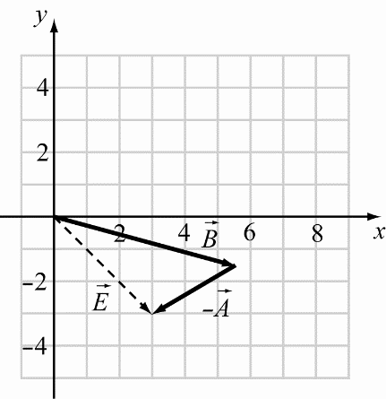

**RESEARCH:** 

**SIMPLIFY:** No simplification is necessary.

**CALCULATE:** By inspection, 

**ROUND:** No rounding is necessary.

**DOUBLE-CHECK:** The resultant vector points from the origin to the fourth quadrant, so its *x*-component should be positive and its *y-*component should be negative. This gives some support to the reasonableness of the answer.

1. **THINK:** When adding vectors, you must add the components separately.

**SKETCH:**



**RESEARCH:** 

**SIMPLIFY:** 

**CALCULATE:** 

**ROUND:** The answers are precise, so no rounding is necessary.

**DOUBLE-CHECK:** The calculation seems consistent with the provided figure.

1. **THINK:** When subtracting vectors, you must subtract the *x* and *y* components separately.

**SKETCH:**

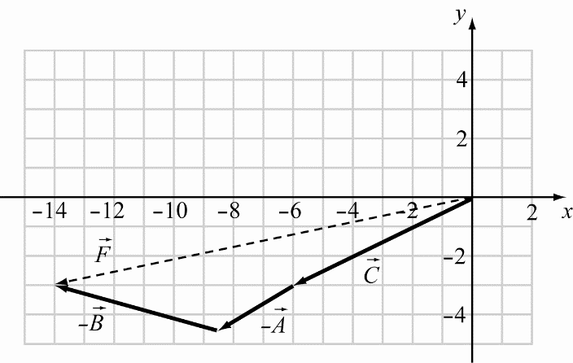

**RESEARCH:**  and . The length is computed using  with

**SIMPLIFY:** 

**CALCULATE:** 





**ROUND:** To two significant figures, the length ofis 14.

**DOUBLE-CHECK:** The size of  is reasonable.

1. **THINK:** The two vectors are  and . Sketch and find the magnitudes.

**SKETCH:**

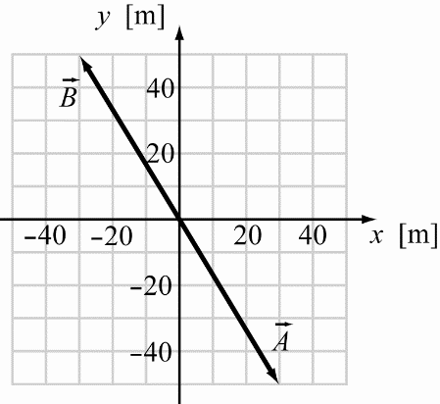

**RESEARCH:** The length of a vector  is 

**SIMPLIFY:**  

**CALCULATE:**  

**ROUND: **, 

**DOUBLE-CHECK:** The calculated magnitudes are larger than the lengths of the component vectors, and are less than the sum of the lengths of the component vectors. Also, the vectors are opposites, so they should have the same length.

1. **THINK:** Use trigonometry to find the angles as indicated in the sketch below. .

**SKETCH:**

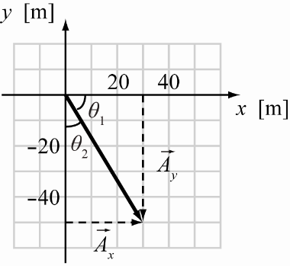

**RESEARCH:** 

**SIMPLIFY:** 

**CALCULATE:** 

**ROUND:** Drop the signs of the angles and just use their size: 

**DOUBLE-CHECK:** The two angles add up to 90˚, which they should. The answers are reasonable.

1. **THINK:** The two vectors are  and . Sketch and find the magnitudes.

**SKETCH:**

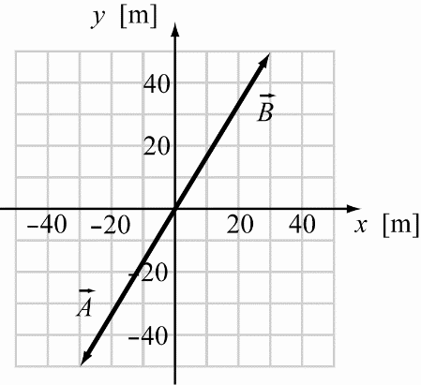

**RESEARCH:** 

**SIMPLIFY:** , 

**CALCULATE:** 

**ROUND:** 

**DOUBLE-CHECK:** The magnitudes are bigger than individual components, but not bigger than the sum of the components. Therefore, the answers are reasonable.

1. **THINK:** Using trigonometry find the angles indicated in the diagram below. The vector.

**SKETCH:**

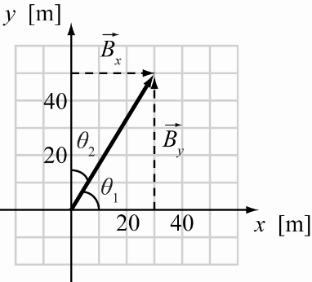

**RESEARCH:** 

**SIMPLIFY:** , , 

**CALCULATE:** 

**ROUND:** , 

**DOUBLE-CHECK:** The angles sum to 90°, which is expected from the sketch. Therefore, the answers are reasonable.

1. **THINK:** The two vectors are  and . Find the magnitude and angle with respect to the positive *x*-axis.

**SKETCH:**

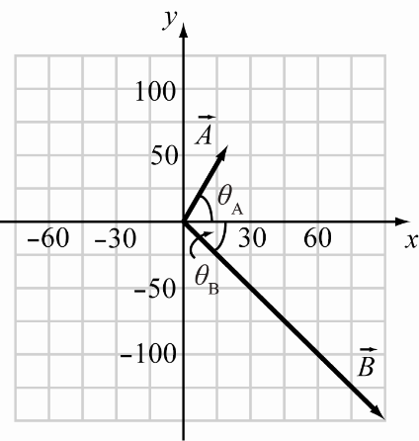

**RESEARCH:** For any vector , the magnitude is given by the formula and the angle  made with the *x*-axis is such that

**SIMPLIFY:**   

**CALCULATE: **



**ROUND:** Three significant figures:  or 

**DOUBLE-CHECK:** Each magnitude is greater than the components but less than the sum of the components, and the angles place the vectors in the proper quadrants.

1. **THINK:** Add the components of the vectors. Find the magnitude and the angle from the positive *x*-axis of the resultant vector.  and 

**SKETCH:**

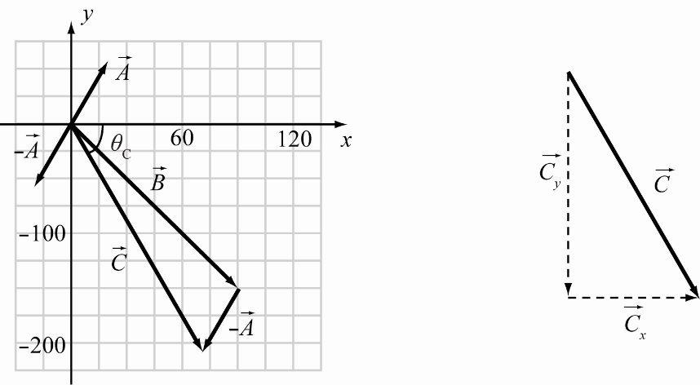

**RESEARCH:**   with  and ,  .

**SIMPLIFY:**   

**CALCULATE: **   and .

**ROUND: ** or 

**DOUBLE-CHECK:** The magnitude is greater than each component but less than the sum of the components and the angle is also in the correct quadrant. The answer is reasonable.

1. **THINK:** Add the components of the vectors (with applicable multiplication of each vector). Find the magnitude and the angle from the positive *x*-axis of the resultant vector.  and 

**SKETCH:**

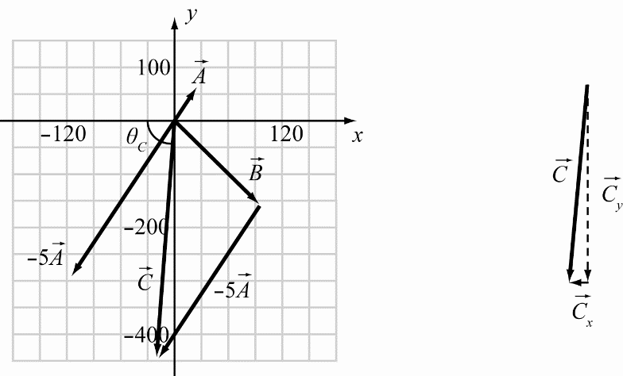

**RESEARCH:**   with  and   .

**SIMPLIFY:** , ,  

**CALCULATE:** 





**ROUND: ** or 

**DOUBLE-CHECK:** The magnitude is greater than each component but less than the sum of the components and the angle is also in the correct quadrant. The answer is reasonable.

1. **THINK:** Add the components of the vectors (with applicable multiplication of each vector). Find the magnitude and the angle from the positive *x*-axis of the resultant vector.  and .

**SKETCH:**

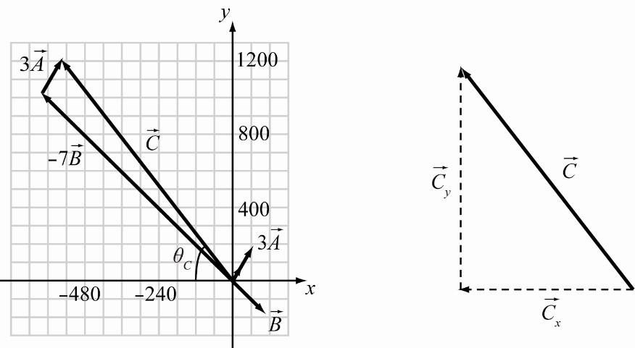

**RESEARCH:**   with  and   .

**SIMPLIFY:** , , 

**CALCULATE:** 





**ROUND:** 

**DOUBLE-CHECK:** The magnitude is greater than each component but less than the sum of the components and the angle is also in the correct quadrant.

1. **THINK:** The scalar product of two vectors equals the length of the two vectors times the cosine of the angle between them. Geometrically, think of the absolute value of the scalar product as the length of the projection of vector  onto vector  times the length of vector, or the area of a rectangle with one side the length of vector and the other side the length of the projection of vector  onto vector . Algebraically, use the formula to find the scalar product from the components, which can be read from the graphs.

**SKETCH:** Using the geometric interpretation, sketch the projection of vector  onto vectorand then draw the corresponding rectangular area, for instance for case (e):

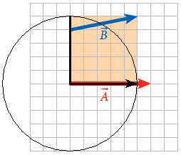

Note, however, that this method of finding the scalar product is cumbersome and does not readily produce exact results. The algebraic approach is much more efficient.

**RESEARCH:** Use the formula to find the scalar product from the components, which can be read from the graphs.  in all cases. In (a), ; in (b), ; in (c), ; in (d), ; in (e), ; and in (f), .

**SIMPLIFY:** Using the formula, find that in part (a), . In part (b), . In part (c), . In part (d), . In part (e), . Finally, in part (f), .

**CALCULATE:** Performing the multiplication and addition as shown above, the scalar product in (a) is 6 units, in (b) it is 0 units, and in part (c) the scalar product is 12 units. In parts (d), (e), and (f), the scalar products are −36 units, 30 units, and 6 units, respectively. The one with the largest absolute value is case (d), 

**ROUND:** Rounding is not required in this problem.

**DOUBLE-CHECK:** Double-check by looking at the rectangles with sides the length of vectorand the length of the projection of vector  onto vector. The results agree with what was calculated using the formula.

1. When the scalar products are evaluated as described in the preceding solution, the one with the smallest absolute value is case (b), where  It is characteristic of the scalar product that it comes out zero for perpendicular vectors, and zero is of course the smallest possible absolute value.
2. The vector product of two non-parallel vectors  and  that lie in the *xy*-plane is a vector in the *z*-direction. As given by Eq. (1.32), the magnitude of that vector is 
3. 
4. 
5. 
6. 
7. 
8. 

The largest absolute value of a vector product is case (a).

1. When the vector products are evaluated as described in Solution 1.109, the one with the smallest absolute value is case (d). It is characteristic of the vector product that it comes out zero for parallel or antiparallel vectors, and zero is of course the smallest possible absolute value.
2. Taking the absolute value and ranking in order from least to greatest, we find that  This gives us the ordering from least to greatest of the absolute value of the scalar product in parts b, a = f, c, e, and d.
3. Ranking the absolute values found in Solution 1.109 in order from least to greatest, we find that  This gives us the ordering from least to greatest of the absolute value of the vector product in parts d, e, c, b, f, and a.
4. **THINK:** We are given the change in the star’s radius. So, if we can express the surface area, circumference, and volume in terms of the radius, we can find by what factors these change as the radius changes.

**SKETCH:** We can think of the star as a sphere in space with radius *r*.

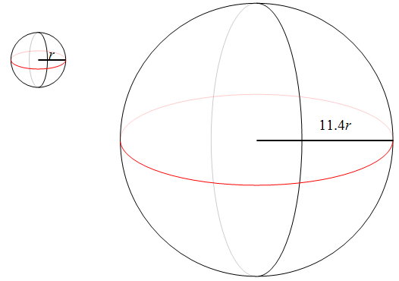

**RESEARCH:** We can use the formulas for volume and surface area of a sphere given in Appendix A. We find that the volume of the sphere on the left is  and its surface area is . Similarly, the volume of the sphere on the right is and its surface area is . The circumference of a sphere is the same as the circumference of a great circle around it (shown in red in the sketch). Finding the radius of the circle will give us the radius of the sphere. Using this method, we find that the circumference of the sphere on the left is, while the sphere on the right has a circumference of .

**SIMPLIFY:** We use algebra to find the volume, surface area, and circumference of the larger sphere in terms of the volume, surface area, and circumference of the smaller sphere. (a) We find the surface area of the sphere on the right is  (b) The circumference of   
the larger sphere is . (c) The volume of the larger sphere is .

**CALCULATE:** Since we don’t know the star’s original radius, we take the ratio of the new value divided by the old value to get the factor by which the surface area, volume, and circumference have increased. In part (a), we find that the ratio of the new surface area to the original surface area is . (b) Similarly, we can divide the new circumference by the original one to get . (c) The new volume divided by the original volume is .

**ROUND:** For all of these calculations, we round to three significant figures. This gives us that (a) the surface area has increased by a factor of130., (b) the circumference has increased by a factor of 11.4, and (c) the volume has increased by a factor of .

**DOUBLE-CHECK:** Think about what these values represent. The circumference is a one-dimensional quantity, with units such as km, which is proportional to *r*. The surface area is a two-dimensional quantity with units such as , and is proportional to . The volume is a three-dimensional quantity with units such as  and is proportional to . So it makes sense that, when we increase the radius by a given amount (11.4 in this case), the circumference increases in proportion to that amount, while the surface area increases by that amount squared, and the volume increases by the cube of that amount.

1. The circumference is directly proportional to the radius.
2. The surface area is proportional to the square of the radius and therefore to the square of the circumference. It will increase by a factor of .
3. The radius is directly proportional to the circumference. It will increase by a factor of 12.5.
4. The volume is proportional to the cube of the radius and therefore to the cube of the circumference. It will increase by a factor of .
5. The volume is proportional to the cube of the radius, so if the volume increases by a factor of 872, then the radius increases by a factor of 
6. The surface area is proportional to the square of the radius. It will increase by a factor of .
7. The circumference is directly proportional to the radius. It will increase by a factor of 9.55.
8. The diameter is directly proportional to the radius. It will increase by a factor of 9.55.
9. The volume is proportional to the cube of the radius, so if the volume increases by a factor of 274, then the radius increases by a factor of 
10. The volume is proportional to the cube of the radius. It will increase by a factor of.
11. The density is *inversely* proportional to the volume. It will decrease by a factor of.